VISTA Setup
- Copy/sftp the vista.tar.gz file in to /home/donsys directory by donsys user
- Login to the server using Putty by donsys user.
- Un TAR the vista.tar.gz file using below screenshot command ( tar -xvzf vista.tar.gz)
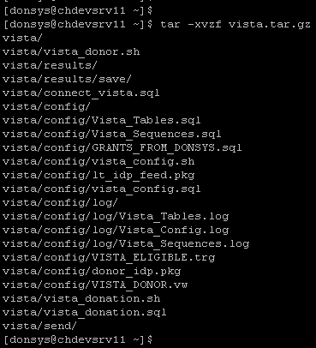
- All required configuration files, shell scripts & required sub directories will extract into vista directory under /home/donsys directory
- Run the below screenshot command to create and configure the vista environment in the donor database.
- Shell script will prompt you for database name. Enter pdon or qdon or tdon
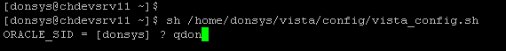
- It will setup the OPS$VISTA schema in the database with required grants & synonyms
- Verify all the log files under /home/donsys/vista/config/log directory for any errors
- Setup the vista_donation.sh & vista_donor.sh shell scripts in CRON Job like below screenshot
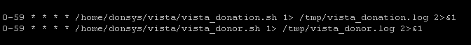
- Need to modify the shell scripts according to database names etc..
- Please Contact Mediware Tech Support If any issues.

